Question 1
2 pts
What characterizes a thread (fill in all correct choices)?
Group of answer choices
- Is created with fork()
- Exists within a process
- Has a private stack
- Has a private heap
- Is light weight
- Threads have separate adress spaces
- Has a private process ID
- Has a private program counter

Question 2
1 pts
If a program is using multiple threads but only one CPU core is available, what will happen?
Group of answer choices
- The program will crash
- All threads will run simultaneously
- The operating system will schedule them alternately, leading to no real speedup
- Only one of the threads will execute, while the other remains idle

Question 3
1 pts
What problem occurs if multiple threads update a shared variable without synchronization?
Group of answer choices
- Deadlock
- Race condition
- Cache coherency
- Stack overflow

Question 4
2 pts
Explain what the cache coherency problem is on multicore computers.
Answer
A cache coherency problem occurs on multicore systems because each core has its own private cache that may store copies of the same memory location.
If one core modifies a cached value, the other cores may still have outdated copies of that variable in their caches. This leads to inconsistent data, where different cores see different values for the same memory location.

Question 5
1 pts
What is the benefit of letting a thread create additional threads?
Group of answer choices
- It prevents race conditions
- It reduces synchronization overhead
- Global broadcast operations will be more efficient
- It allows for hierarchical parallelism, useful in recursive problems
- It ensures each thread has an equal amount of work

Question 6
2 pts
In what ways can a thread terminate? (Mark all correct alternatives.)
Group of answer choices
- The thread calls pthread_exit()
- Returning from the function it was given in pthread_create()
- The parent thread calls pthread_exit()
- The parent thread calls pthread_kill()
- The parent process is terminated
- The thread is cancelled by another thread calling pthread_cancel()
- The thread calls pthread_join()
- The thread calls pthread_cancel()

Question 7
2 pts
When creating a thread the function pthread_create() is called with a function as an argument where the thread starts to execute. The function header should have the following form:
void *threadfunc(void *arg)
Explain how you can send and receive data to/from a thread function.
Answer
You can send data to a thread by passing a pointer as the last argument to pthread_create(). Since the thread function receives a void *arg, inside the thread you cast it to the correct type such as an int * or a pointer to a struct.
You can receive data from a thread either by having the thread return a void * pointer, which is collected using pthread_join(), or by passing a pointer to shared data and letting the thread write the result there.

Question 8
1 pts
Why is parallelizing prime number calculation challenging?
Group of answer choices
- Prime number tests are inherently sequential
- The amount of operations per number is not predictable in advance
- Memory consumption increases exponentially with more threads
- The problem is not suitable for parallelism
- The workload per thread is too small to make it worthwhile
- The computational complexity increases exponentially

Question 9
2 pts
Assume that you want to compute all prime numbers up to M. Describe a way to load balance the computations if you are running on 8 threads on an 8 core computer.
Answer

Because the cost of testing each number for primality is not predictable, a static division of numbers may lead to load imbalance. A good solution is to use dynamic work distribution, where threads repeatedly fetch the next number (or block of numbers) from a shared counter or work queue. This ensures that threads that finish early can continue taking new work, keeping all cores busy.

Question 10
4 pts
Parallelize the pi-program with Pthreads:
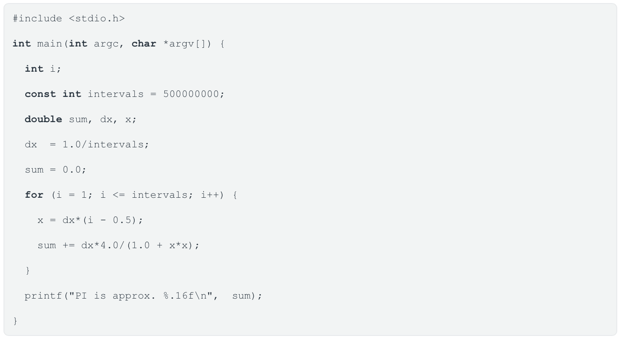

Answer
#include <stdio.h>
#include <pthread.h>

#define NTHREADS 8
#define intervals 500000000

double partial[NTHREADS];
double dx;

void *worker(void *arg) {
int tid = *(int *)arg;
int start = tid * intervals / NTHREADS + 1;
int end = (tid + 1) * intervals / NTHREADS;

double x, sum = 0.0;

for (int i = start; i <= end; i++) {
x = dx * (i - 0.5);
sum += dx * 4.0 / (1.0 + x * x);
}

partial[tid] = sum;
return NULL;
}

int main() {
pthread_t threads[NTHREADS];
int id[NTHREADS];
double pi = 0.0;

dx = 1.0 / intervals;

for (int t = 0; t < NTHREADS; t++) {
id[t] = t;
pthread_create(&threads[t], NULL, worker, &id[t]);
}

for (int t = 0; t < NTHREADS; t++) {
pthread_join(threads[t], NULL);
pi += partial[t];
}

printf("PI is approx. %.16f\n", pi);
return 0;
}
Question 11
4 pts
In the program below one thread is doing work while the other is constantly reading a global variable DoItNow until it changes to 1. The other thread is then consuming CPU cycles without any productive work. Change this program using a condition variable and putting this thread to sleep so it will not consume CPU cycles. The thread should wake up when DoItNow is set to 1 by the first thread. Simplify the code as much as possible (think about the loop structure).
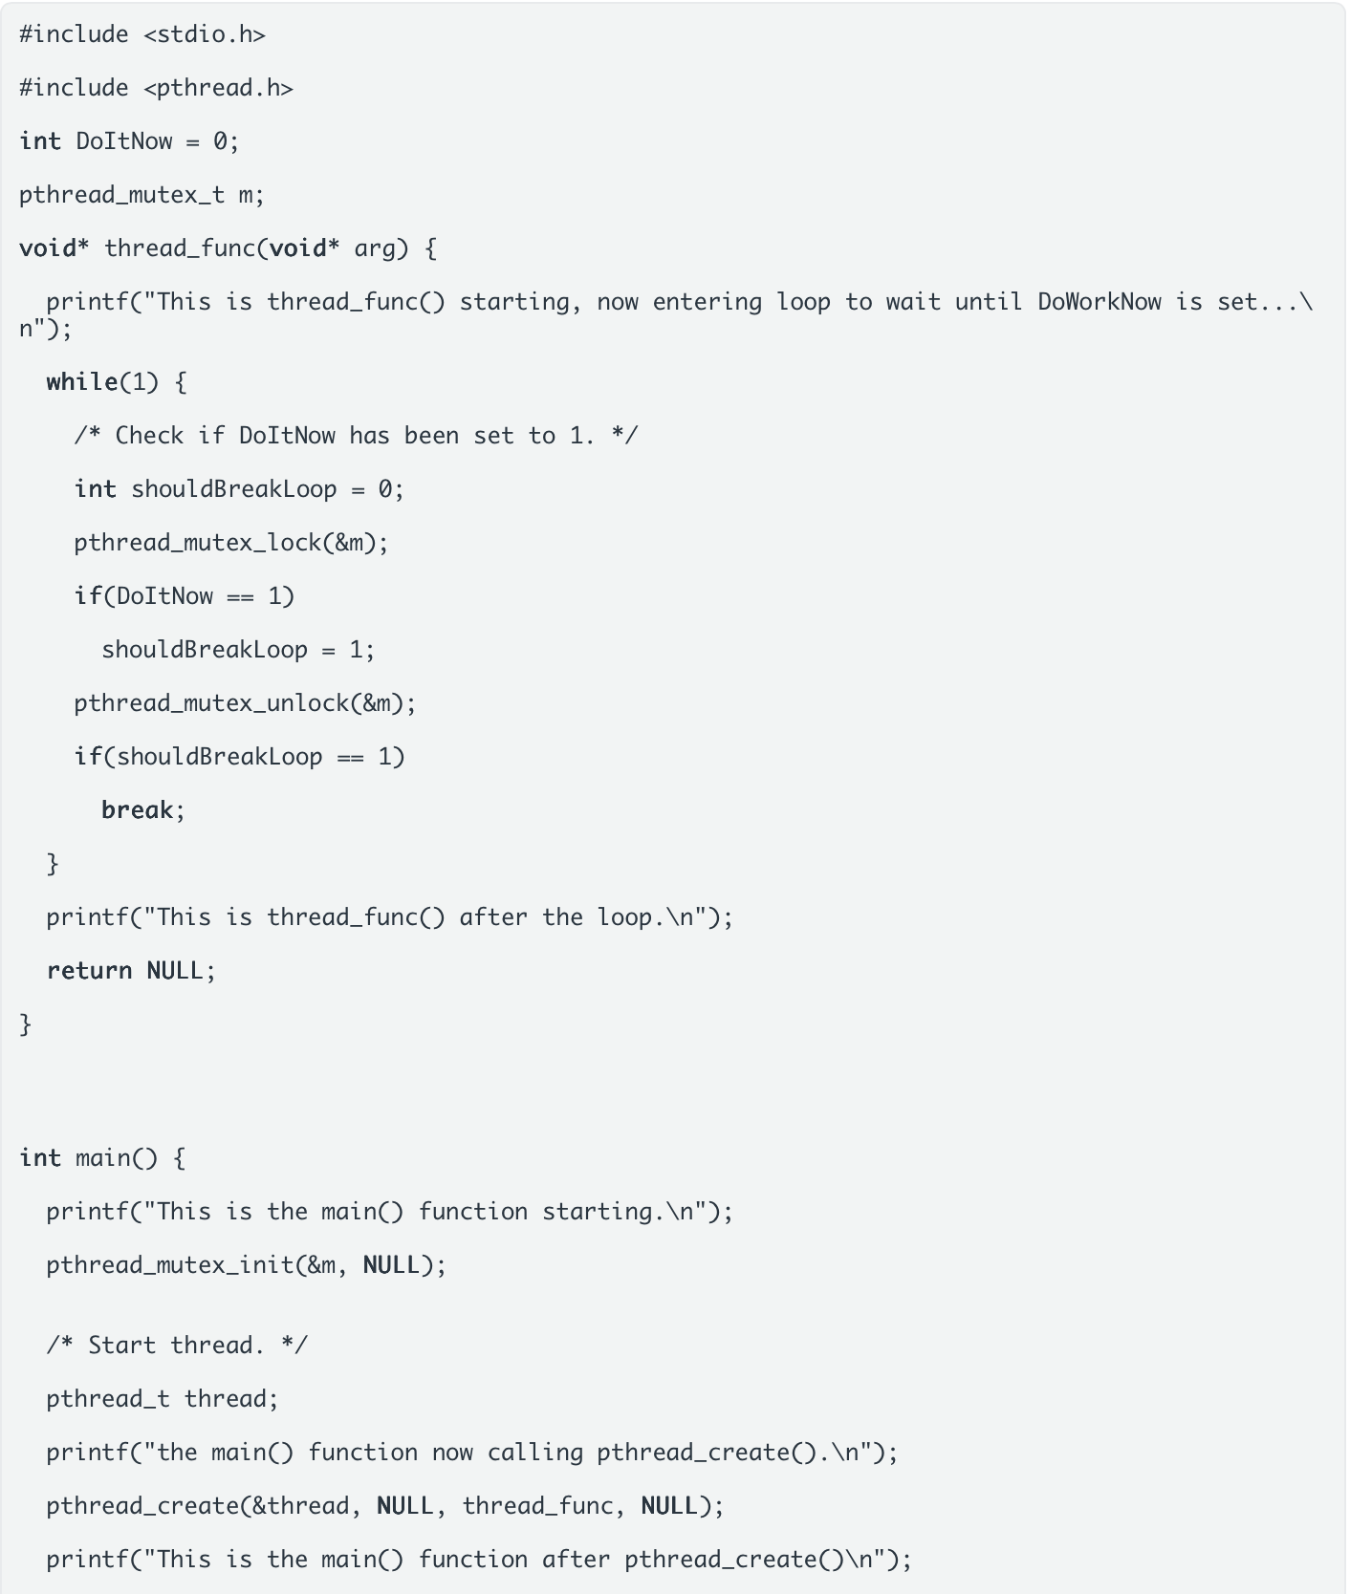

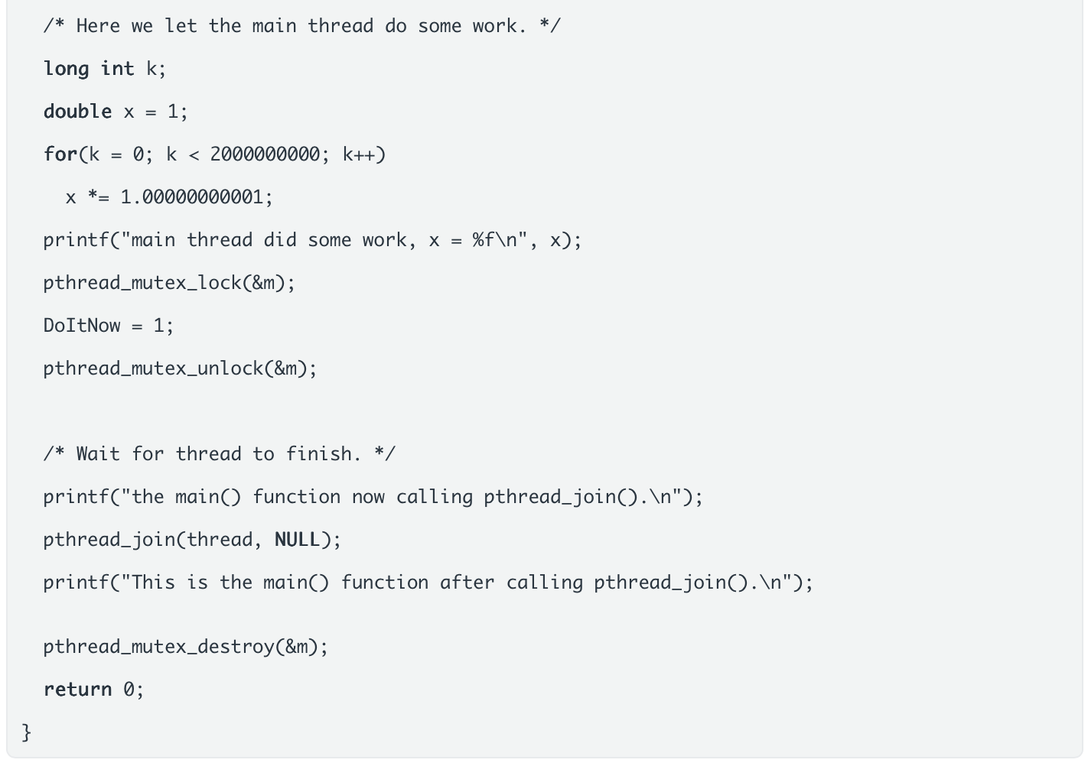

Question 12
6 pts
Parallelize the merge_sort function with Pthreads, assume that you will have 16 cores available:

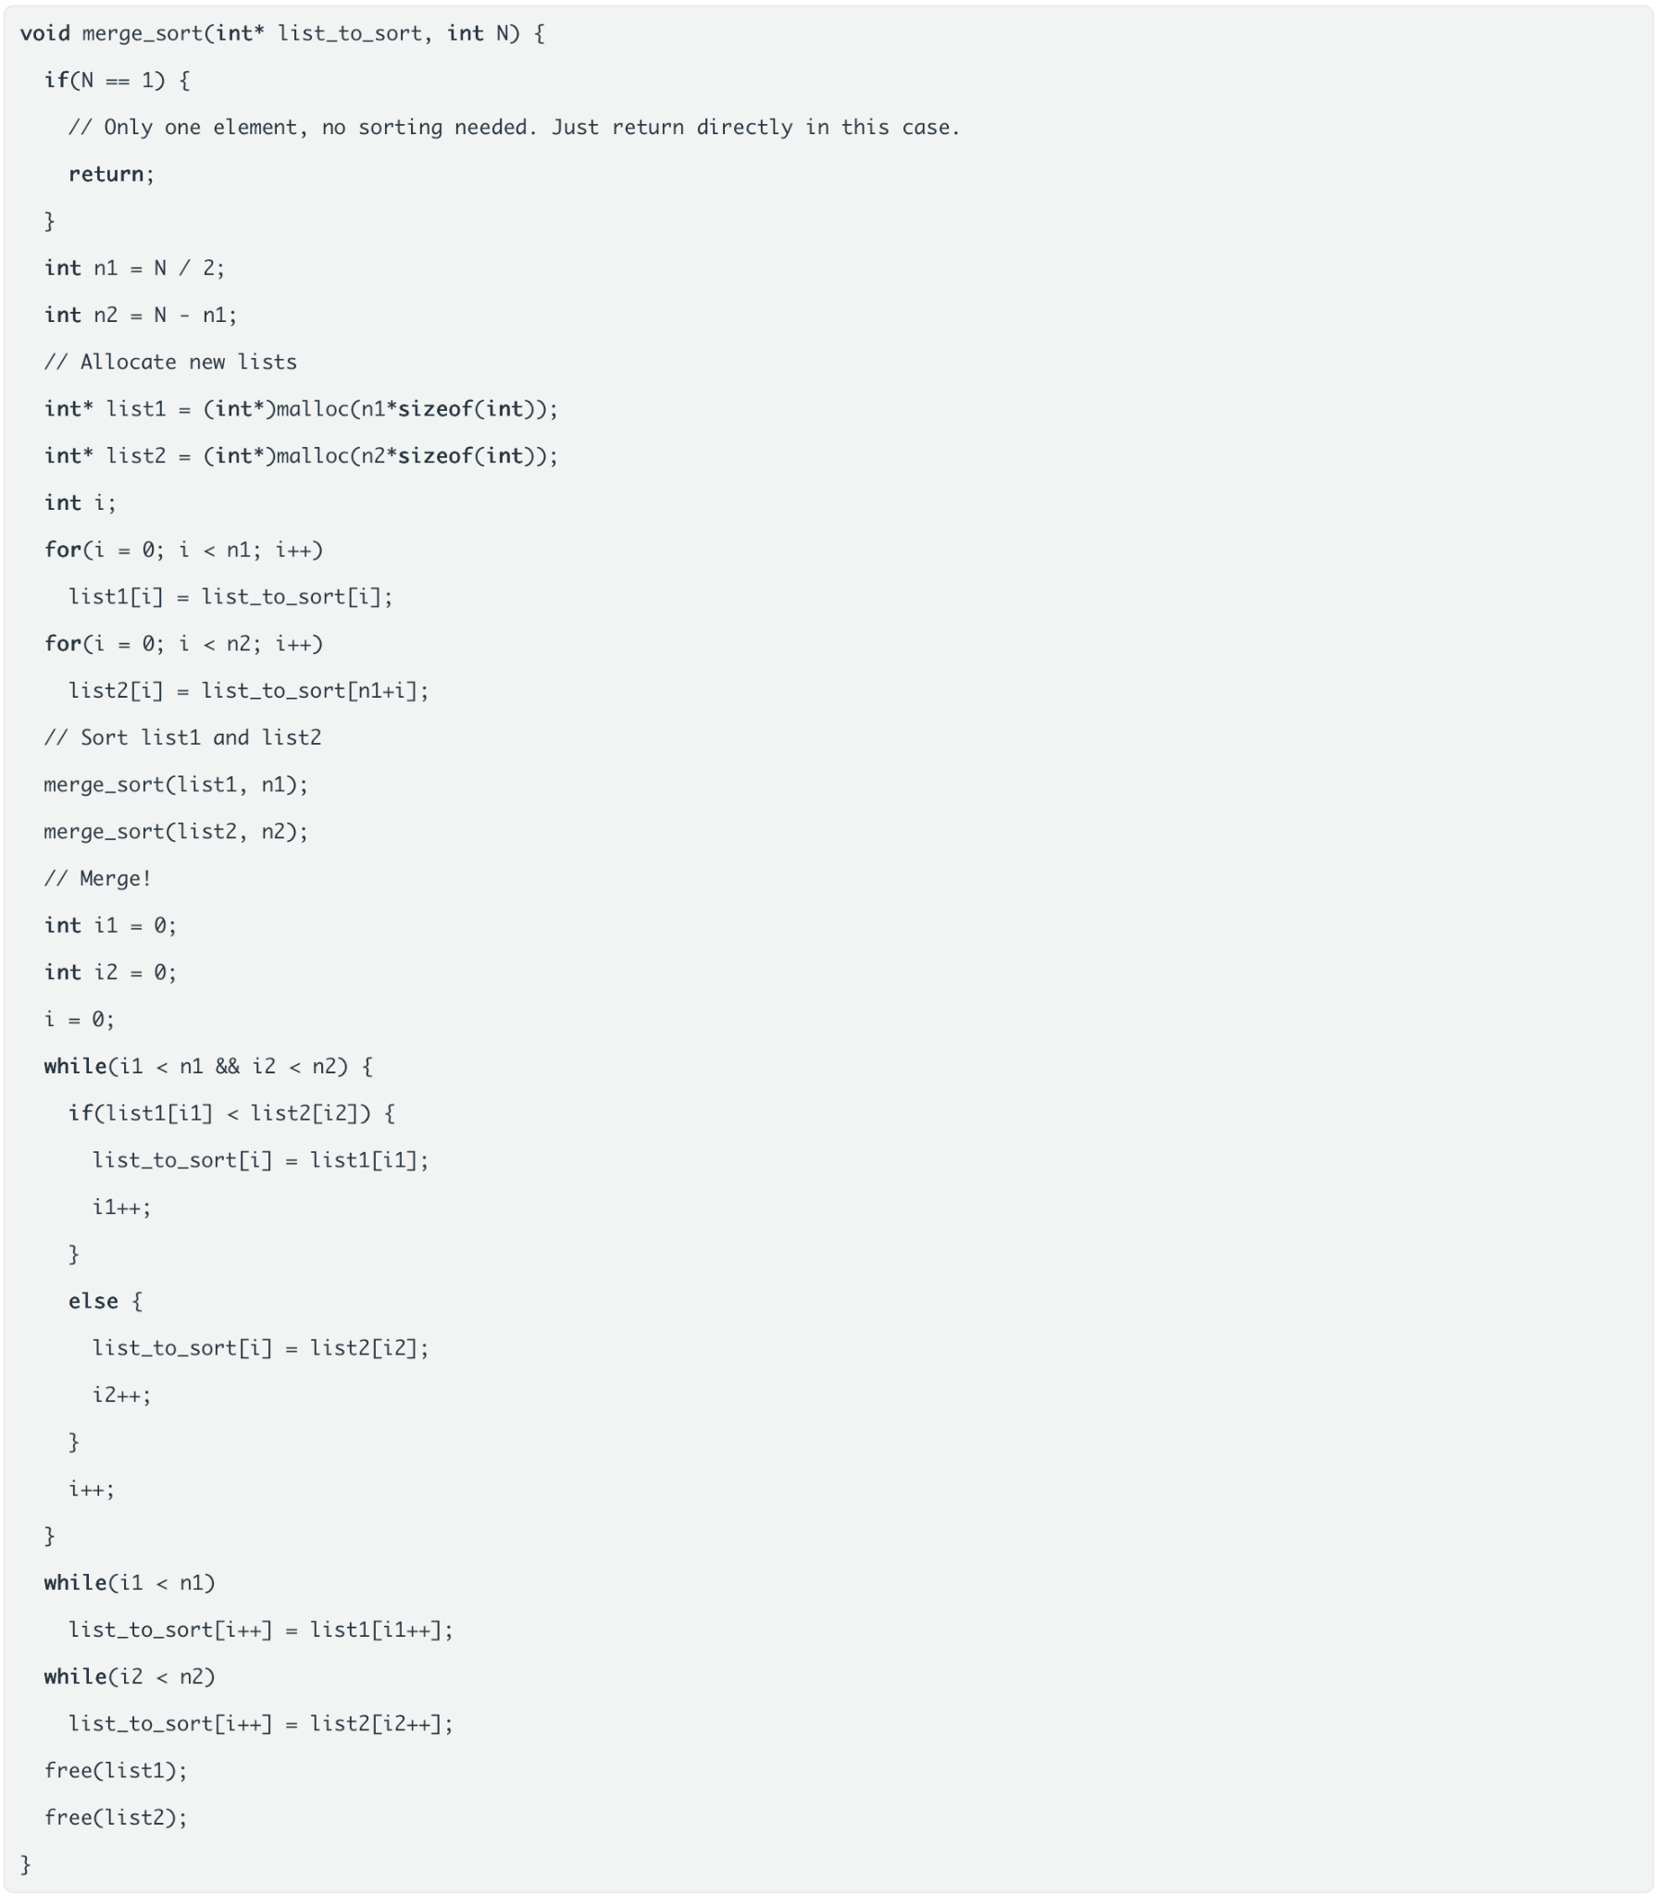

Question 13
2 pts
To get good parallel performance on a multicore computer using Pthreads what should you do (mark all applicable alternatives):
Group of answer choices
- Keep good cache locality on threads
- Avoid frequent malloc/free on threads
- Avoid frequent creation/termination of threads
- Avoid frequent synchronization of threads
- Avoid having too many threads
- Keep good load balance between threads
- Avoid large serial sections
- Find and assign large tasks for the threads

